TC-PM-003
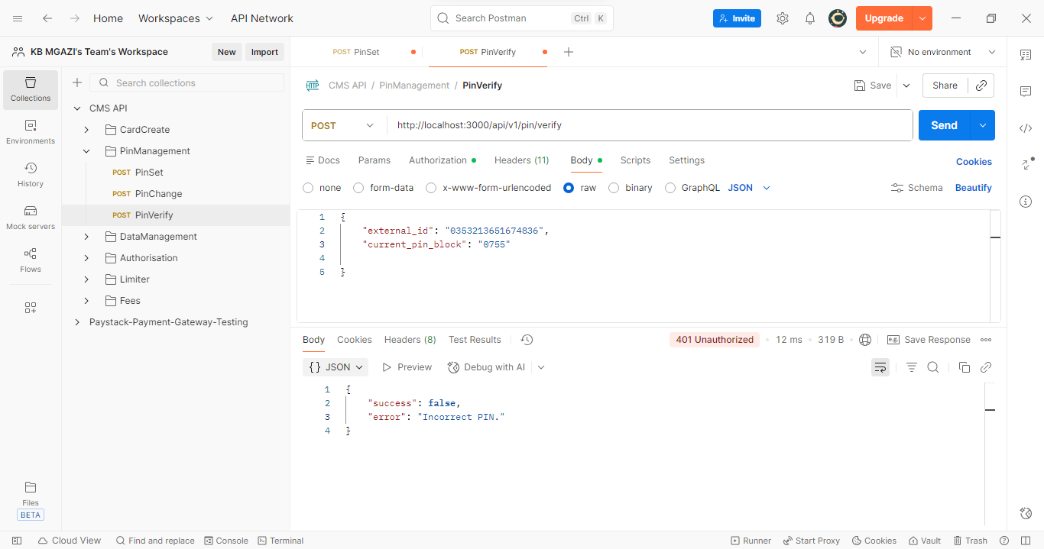
Request:
{
"external_id": "0353213651674836",
"current_pin_block": "0755"

}
Response:
{
"success": false,
"error": "Incorrect PIN."
}

